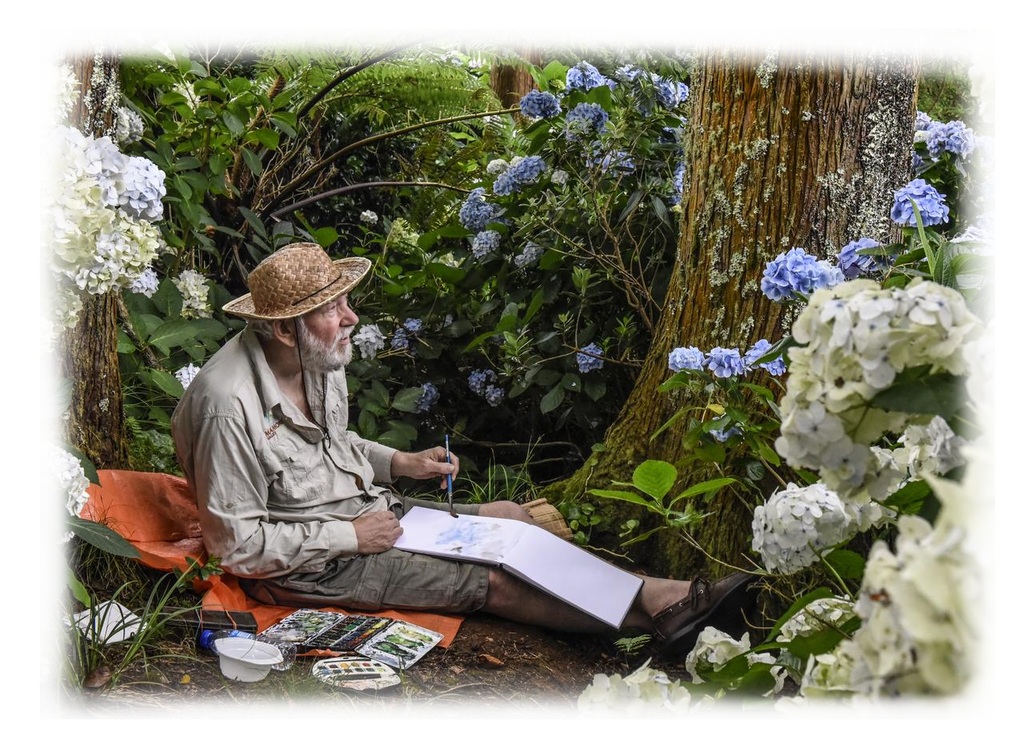
Pieter Adriaans

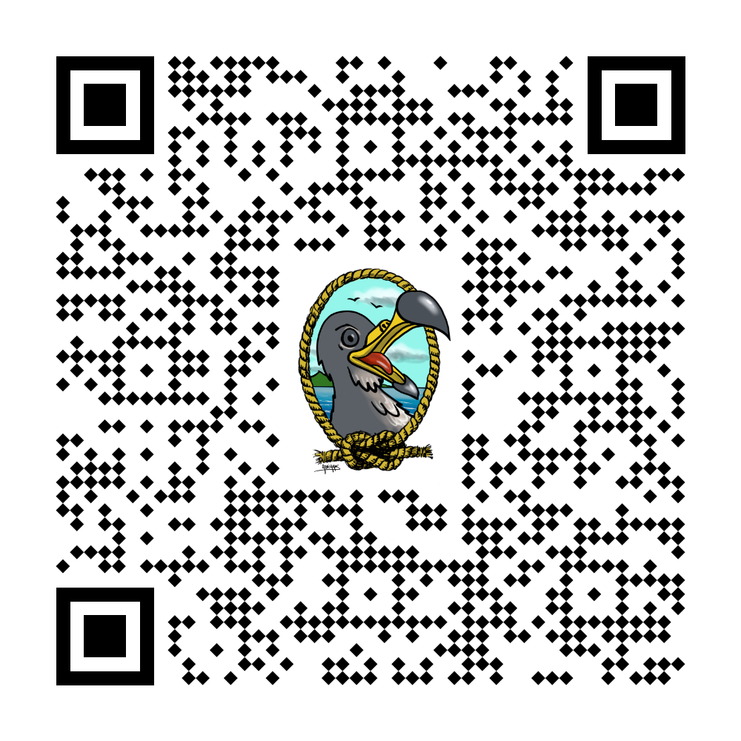
The confrontation with the Azorean landscape and culture has made a major impact on the work of painter-philosopher, musician Pieter Adriaans (1955). In 2015 Pieter and his wife Rini opened a cultural center in the old cheese factory in Santo Antonio. The stunning landscape paintings he has made since 2002 form the heart of the collection and are on permanent display. Apart from that studio “De Kaasfabriek” organizes expositions, concerts, courses and other activities. In 2021 the couple opened Art Restaurant Manezinho at the rocky coast of Urzelina at the south side of São Jorge. Here they offer music, good food and a permanent exposition of artworks.
In 2026 Pieter published a comic book:
João Cagarro and the Secret of Santa Barbara.
Want to know more?
Scan the QR code with your phone.

Interested in buying an original painting
or print by Pieter.
Want to know more?
Scan the QR code with your phone

